Brighton Hoopstars
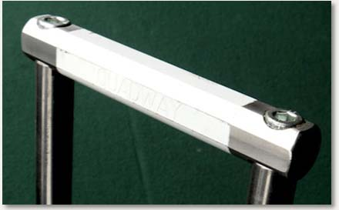

Why not join us on Tuesday Nights 7pm – 9pm?
Now that the days are longer and the weather warmer, we are back playing Tuesday nights. We have music, hoops and stars (both skilled players and the celestial variety).
We welcome our existing club members but also encourage new people to join us. Two free sessions to see what croquet is all about and then another 4 sessions at $6 per session to see if croquet is for you (applicable from Jan 1st,2022).
Croquet is played not only during working and school hours but also on weekends and in the evenings, so why not come and try it?
Please contact: Peter Woodward (0434 045 948) or www.brightoncroquetsa.com

